a CDN which stands for Content Delivery Network. A CDN is a network of servers scattered across the world that store files, including the jQuery library, and allow other computers to download those files when needed.

jQuery is a JavaScript library, so it has the **.js** file extension.

**<script src="https://code.jquery.com/jquery-3.1.1.js"></script>**

The **$** is used to access jQuery.

$(function() {  
// jQuery code goes here  
});

having the jQuery library in our head section and having defined the document ready event

$("#start").html("Go!");

$("p").hide() // hides all <p> elements  
$(".demo").hide() // hides all elements with class="demo"  
$("#demo").hide() // hides the element with id="demo"

$("div.menu") // all <div> elements with class="menu"  
  
$("p:first") // the first <p> element  
  
$("h1, p") // all <h1> and all <p> elements  
  
$("div p") // all <p> elements that are descendants of a <div> element  
  
$("*") // all elements of the DOM

The **attr()** method is used for getting the value of an attribute.

The **attr()** method also allows us to set a value for an attribute by specifying it as the second parameter.

**text**() sets or returns the text content of selected elements.  
**html**() sets or returns the content of selected elements (including HTML markup).  
**val**() sets or returns the value of form fields.  
**attr**() sets or returns the value of attributes.  
**removeAttr**() removes the specified attribute.

**append**() inserts content at the end of the selected elements.  
**prepend**() inserts content at the beginning of the selected elements.  
**after**() inserts content after the selected elements.  
**before**() inserts content before the selected elements.pv

<p>Some text</p>  
<button>Toggle Class</button>

.red {   
color:red;   
font-weight: bold;  
}

$(function() {  
$("button").click(function() {  
$("p").**toggleClass**("red");  
});  
});

To set multiple CSS properties, the **css**() method uses JSON syntax:

$("p").css({"color": "red", "font-size": "200%"});

The **width**() and **height**() methods get and set the dimensions without the padding, borders and margins.  
The **innerWidth**() and **innerHeight**() methods also include the padding.  
The **outerWidth**() and **outerHeight**() methods include the padding and borders.

CSS:

div {  
width: 300px;  
height: 100px;  
padding: 10px;  
margin: 20px;  
border: 3px solid blue;  
background-color: red;  
color: white;  
}

JS:

$(function() {  
var txt = "";  
txt += "width: " + $("div").width() + " ";  
txt += "height: " + $("div").height() + "<br/>";  
txt += "innerWidth: " + $("div").innerWidth() + " ";  
txt += "innerHeight: " + $("div").innerHeight() + "<br/>";  
txt += "outerWidth: " + $("div").outerWidth() + " ";  
txt += "outerHeight: " + $("div").outerHeight();  
  
$("div").html(txt);  
});

the**Document Object Model (DOM)** is an object oriented model of a page’s logical structure.

Document

|

<html>

|

<head> - <title>

<body> - <h1> <a>

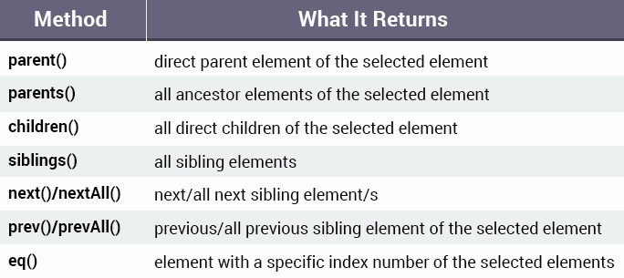

The **eq()** method can be used to select a specific element from multiple selected elements.  
For example, if the page contains multiple div elements and we want to select the third one:

$("div").**eq**(2);

The following are the most commonly used events:  
**Mouse Events:  
click**occurs when an element is clicked.  
**dblclick**occurs when an element is double-clicked.  
**mouseenter**occurs when the mouse pointer is over (enters) the selected element.  
**mouseleave** occurs when the mouse pointer leaves the selected element.  
**mouseover**occurs when the mouse pointer is over the selected element.  
  
**Keyboard Events:  
keydown**occurs when a keyboard key is pressed down.  
**keyup**occurs when a keyboard key is released.  
  
**Form Events**:  
**submit**occurs when a form is submitted.  
**change**occurs when the value of an element has been changed.  
**focus**occurs when an element gets focus.  
**blur**occurs when an element loses focus.  
  
**Document Events**:   
**ready**occurs when the DOM has been loaded.  
**resize**occurs when the browser window changes size.  
**scroll**occurs when the user scrolls in the specified element.

Every event handling function can receive an **event object**, which contains properties and methods related to the event:  
**pageX**, **pageY**the mouse position (X & Y coordinates) at the time the event occurred, relative to the top left of the page.  
**type**the type of the event (e.g. "click").  
**which**the button or key that was pressed.  
**data**any data that was passed in when the event was bound.  
**target**the DOM element that initiated the event.  
**preventDefault**() prevent the default action of the event (e.g., following a link).  
**stopPropagation**() Stop the event from bubbling up to other elements.

“This” represents the current object.